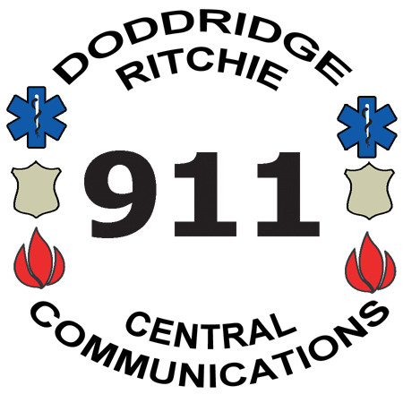

Central Communications, Inc.
4317 Lamberton Road, P.O. Box 516
Pennsboro, WV 26415
Phone: 304-659-3770 Fax: 304-659-3772
Mapping & Addressing: 304-659-2979
www.centrale911.com



Request for Medical Alert
Executive Director
Eric E. Ashcraft

Board of Directors
Samuel Rogers
Clinton Means
Shawn Glaspell
Steve Ritter

Name of Patient: | Phone:

Patient’s Date of Birth: | Height: | Weight:

Address of Patient:
POSTAL Address

PHYSICAL Address

City, State, Zip

Patients’s Condition(s):

Added Directions / Comments:

Contact Person # 1
Name: | Phone:

Address City State Zip

Relation to Patient:

Contact Person # 2
Name: | Phone:

Address City State Zip

Relation to Patient:

Printed Name of Applicant:

Signature: | Date:
Ver. 14 08/01/23

